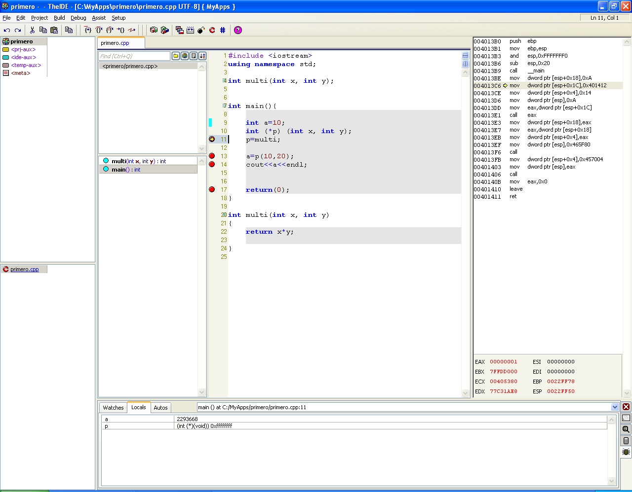
The BreakPoint has stopped the program here.
The value of variable a reported by the debugger is trash➔it should be 10.

